8051(AT89C51) timer1 code + Proteus simulation
This post provides the timer1 code ( using c language ) for 8051 micro-controller ( e-g for AT89C51 or AT89C52 etc ). This code is written in such a way that, whenever timer1 overflows, then an interrupt is generated and in the interrupt service routine a pin named 'Out' is toggled.
The code and Proteus simulation is given in the 'Downloads' section at the bottom of this page. It is assumed that you know how to make an LED blink with 8051 micro-controller. If you don't, then please read this post first.
The circuit required is shown below.
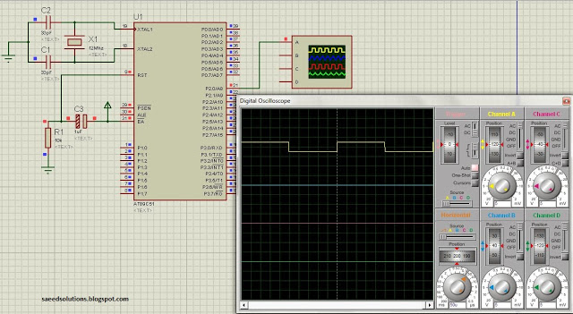
Figure 1. 8051 timer1 example
A crystal of 12 MHz is used here. You can use any crystal value from 3 to 24MHz with 8051. As we know that 8051 micro controller has an architecture which executes an instruction in 12 CPU cycles ^{[1]}, hence this 12Mhz crystal makes this 8051 run at 1.0 MIPS (Million of instructions per second).
P2.0 pin is being used to generate the output , which is a square wave with 500 usec time period. This pin is toggled after every 250 usec in the timer1 interrupt service routine. The code to configure the timer1 of 8051 is shown below.
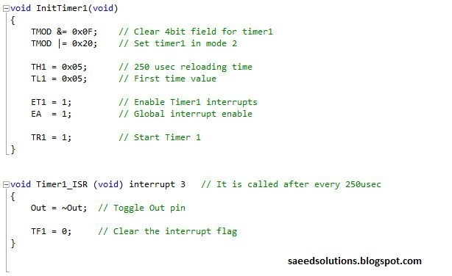
Figure 2. Timer1 code for 8051
In the code above, InitTimer1() function is initializing timer1 of 8051 in mode 2 ( Auto-reload mode ). In this mode timer1 works as 8 bit timer, with its current count saved in TL1 register at all times. Timer1 will count from 0 to 255 value^{[2]} and at 255 to 0 transition, it will overflow and an interrupt will be generated. Also, whenever timer1 overflows, then the value present in the TH1 register is automatically loaded in the TL1 register and timer starts to run again (Hence, the name auto-reload mode).
After timer mode selection, an initial value of 5 is stored in the TL1 register of timer1 as well as in TH1 register. As we have configured 8051 to run at 1 MIPS speed, that is why we know that timer1 is going to increment TL1 register after every 1 usec. So, it takes about 250 usec, after which TL1 register oveflows and an interrupt is generated. This interrupt is handled in the Timer1_ISR function ( which is also shown in the figure 2 ). In the timer1 ISR^{[3]}, Out pin is toggled and interrupt flag is cleared. Hence, whenever timer1 interrupt occurs, Out pin toggles ( which can be seen clearly in figure 1 ).
The code for the main function is shown below.
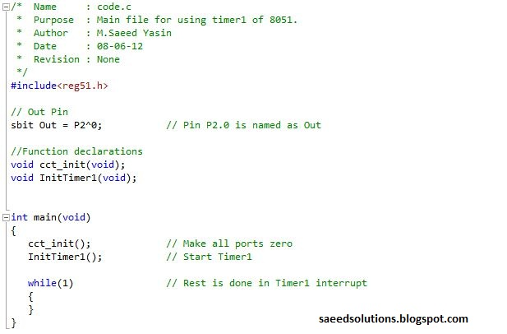
Figure 3. Main code for timer1 of 8051
In the main function, circuit is initialized ( i-e all ports are assigned a value of zero ) and after that, timer1 initializing function is called. Then rest of the work is done in the timer1 ISR^{[3]}.
To read about writing code for timer0 of 8051 click here.
You can leave your comments in the comment section below.

Notes and References
^{[1]} From http://en.wikipedia.org/wiki/Intel_MCS-51
^{[2]} It is assumed here that a value of zero is present in the TH1 register.
^{[3]} Short for Interrupt Service Routine.

8051(AT89C51) timer0 code + Proteus simulation
This post provides the timer0 code ( using c language ) for 8051 micro-controller ( e-g for AT89C51 or AT89C52 etc ). This code is written in such a way that, whenever timer0 overflows, then an interrupt is generated and in the interrupt service routine a pin named 'Out' is toggled.
The code and Proteus simulation is given in the 'Downloads' section at the bottom of this page. It is assumed that you know how to make an LED blink with 8051 micro-controller. If you don't, then please read this post first.
The circuit required is shown below.
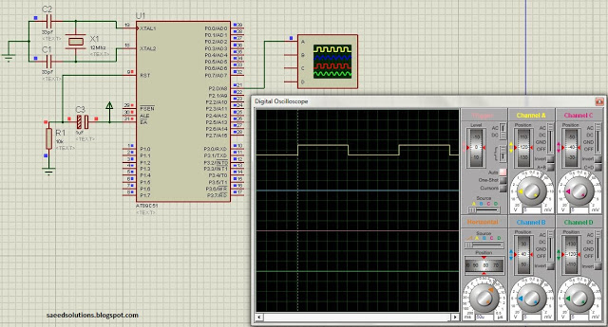
Figure 1. 8051 timer0 example
A crystal of 12 MHz is used here. You can use any crystal value from 3 to 24MHz with 8051. As we know that 8051 micro controller has an architecture which executes an instruction in 12 CPU cycles ^{[1]}, hence this 12Mhz crystal makes this 8051 run at 1.0 MIPS (Million of instructions per second).
P2.0 pin is being used to generate the output , which is a square wave with 500 usec time period. This pin is toggled after every 250 usec in the timer0 interrupt service routine. The code to configure the timer0 of 8051 is shown below.
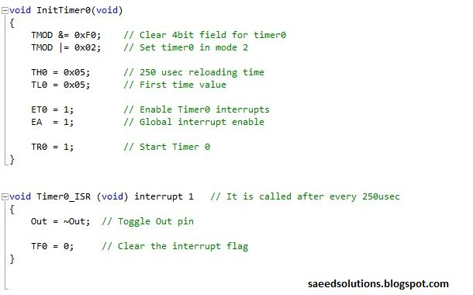
Figure 2. Timer0 code for 8051
In the code above, InitTimer0() function is initializing timer0 of 8051 in mode 2 ( Auto-reload mode ). In this mode timer0 works as 8 bit timer, with its current count saved in TL0 register at all times. Timer0 will count from 0 to 255 value^{[2]} and at 255 to 0 transition, it will overflow and an interrupt will be generated. Also, whenever timer0 overflows, then the value present in the TH0 register is automatically loaded in the TL0 register and timer starts to run again (Hence, the name auto-reload mode).
After timer mode selection, an initial value of 5 is stored in the TL0 register of timer0 as well as in TH0 register. As we have configured 8051 to run at 1 MIPS speed, that is why we know that timer0 is going to increment TL0 register after every 1 usec. So, it takes about 250 usec, after which TL0 register oveflows and an interrupt is generated. This interrupt is handled in the Timer0_ISR function ( which is also shown in the figure 2 ). In the timer0 ISR^{[3]}, Out pin is toggled and interrupt flag is cleared. Hence, whenever timer0 interrupt occurs, Out pin toggles ( which can be seen clearly in figure 1 ).
The code for the main function is shown below.
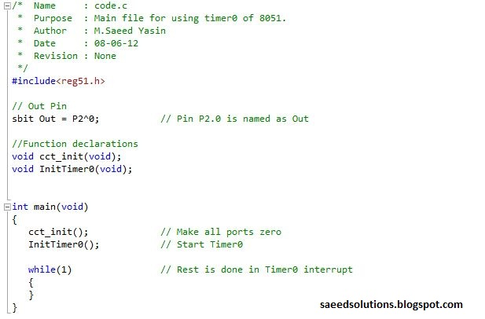
Figure 3. Main code for timer0 of 8051
In the main function, circuit is initialized ( i-e all ports are assigned a value of zero ) and after that, timer0 initializing function is called. Then rest of the work is done in the timer0 ISR^{[3]}.
You can leave your comments in the comment section below.

